Paint n Sip  6th November | 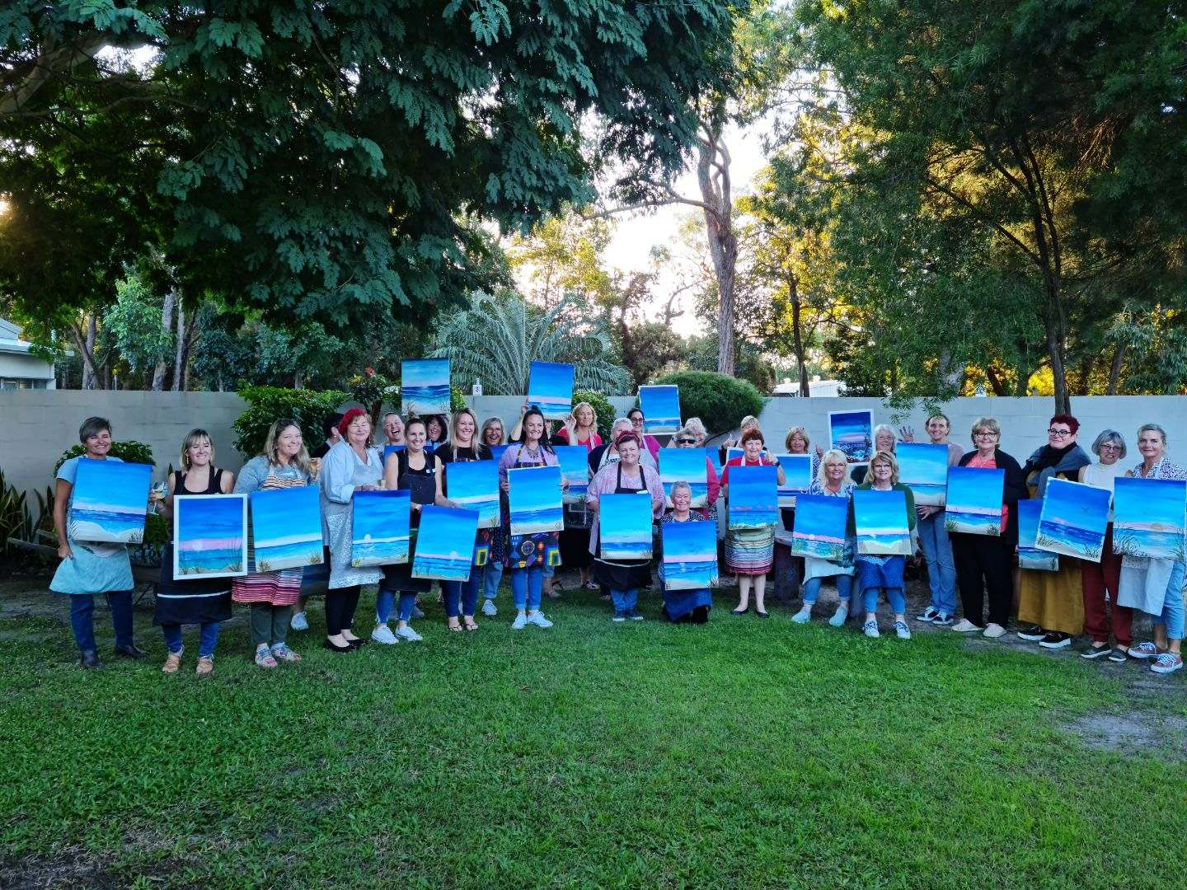
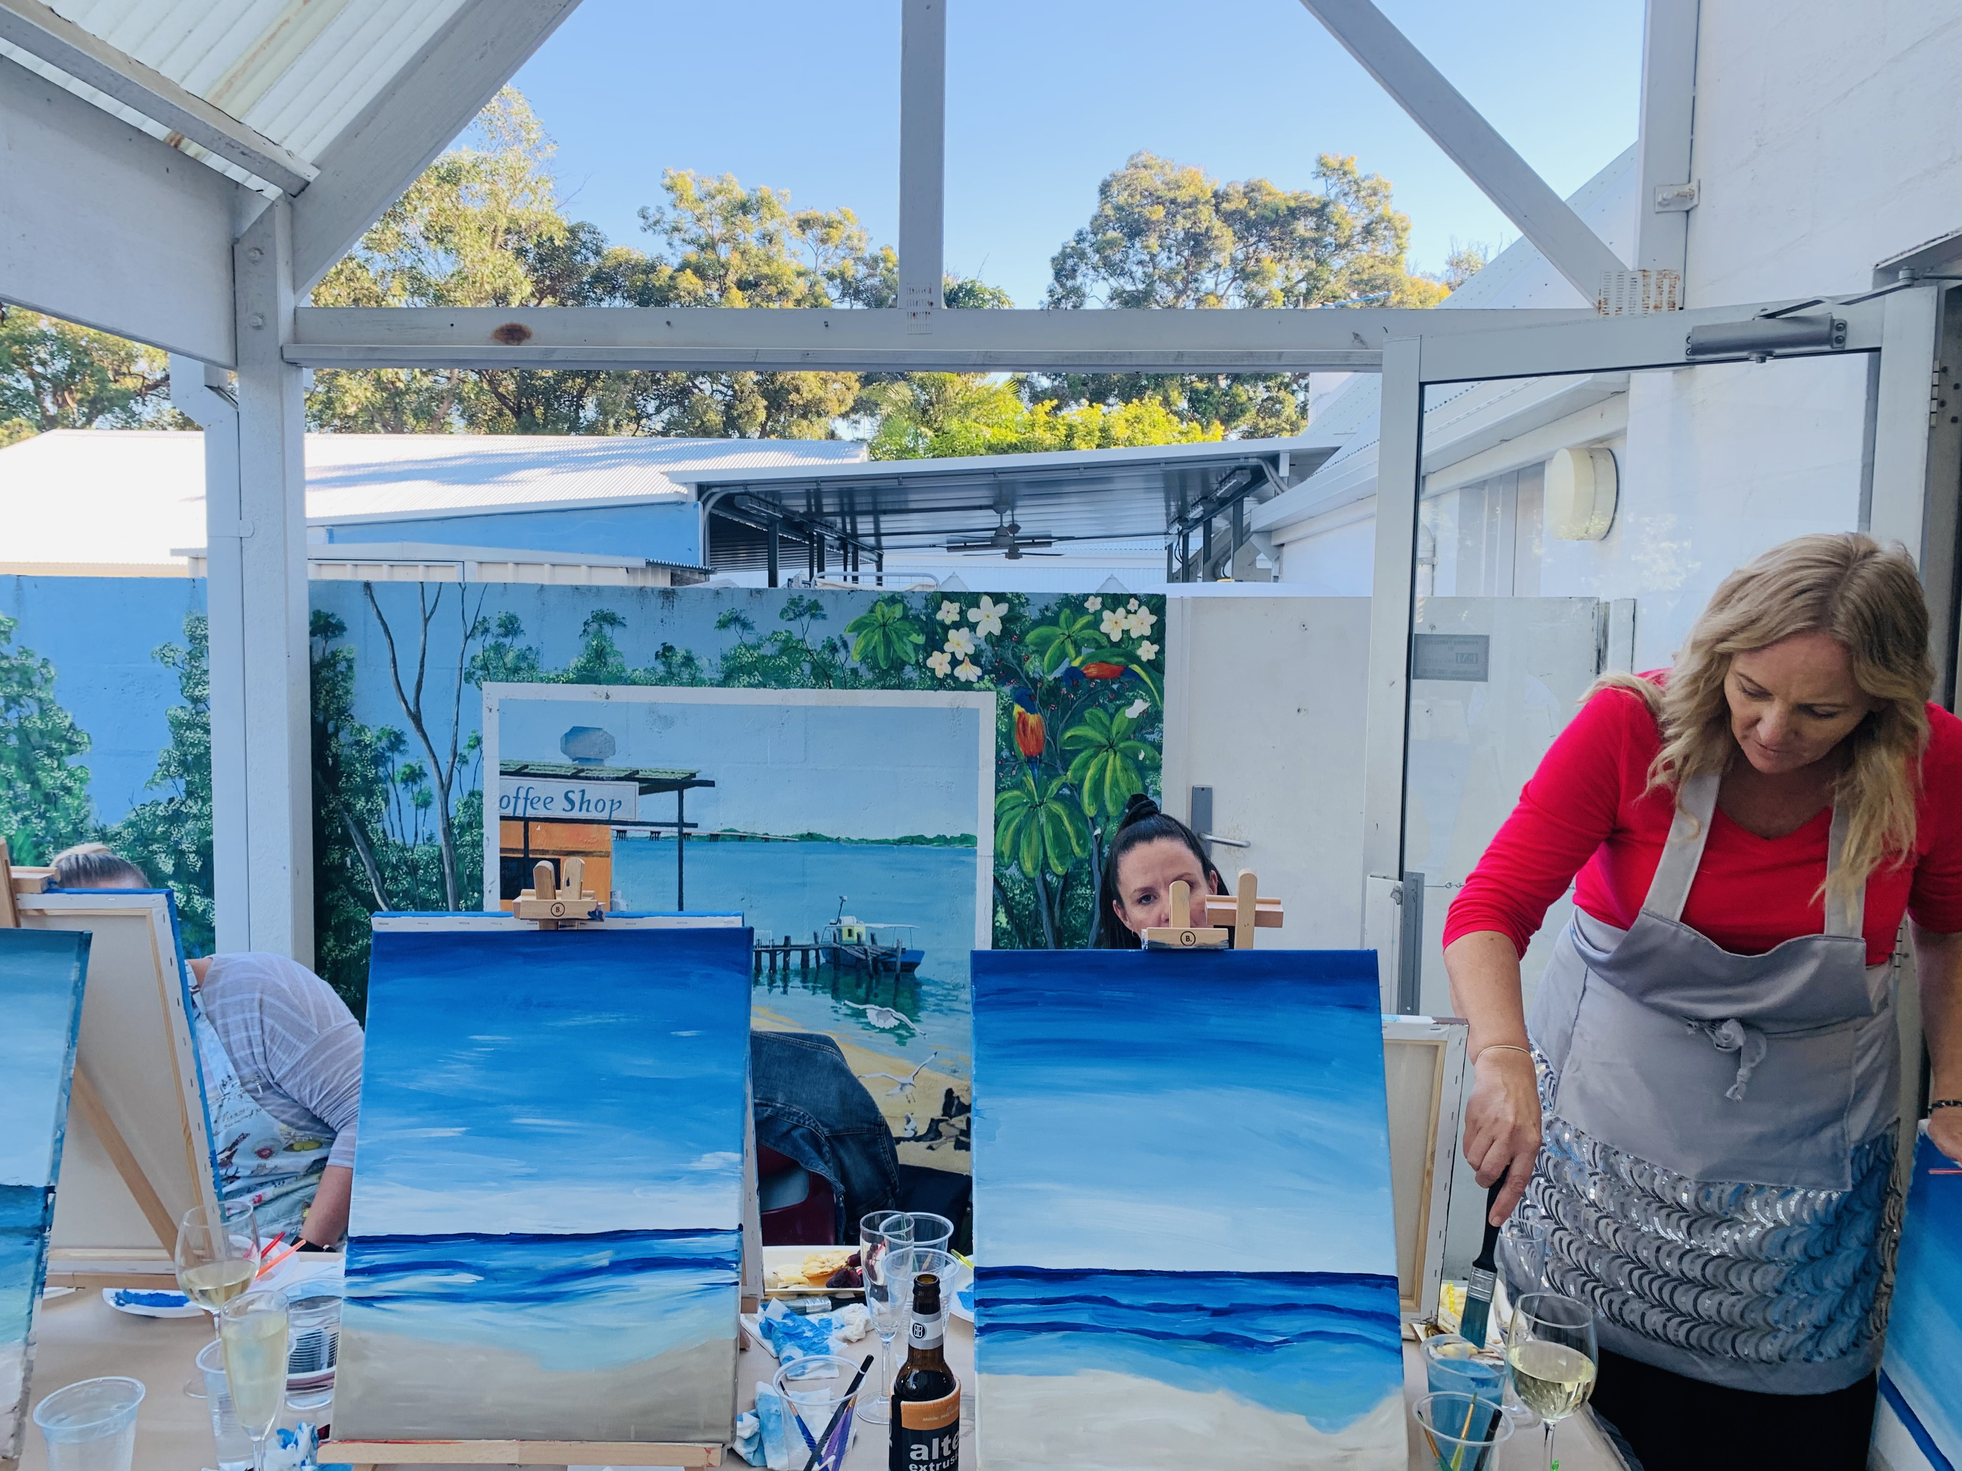 | 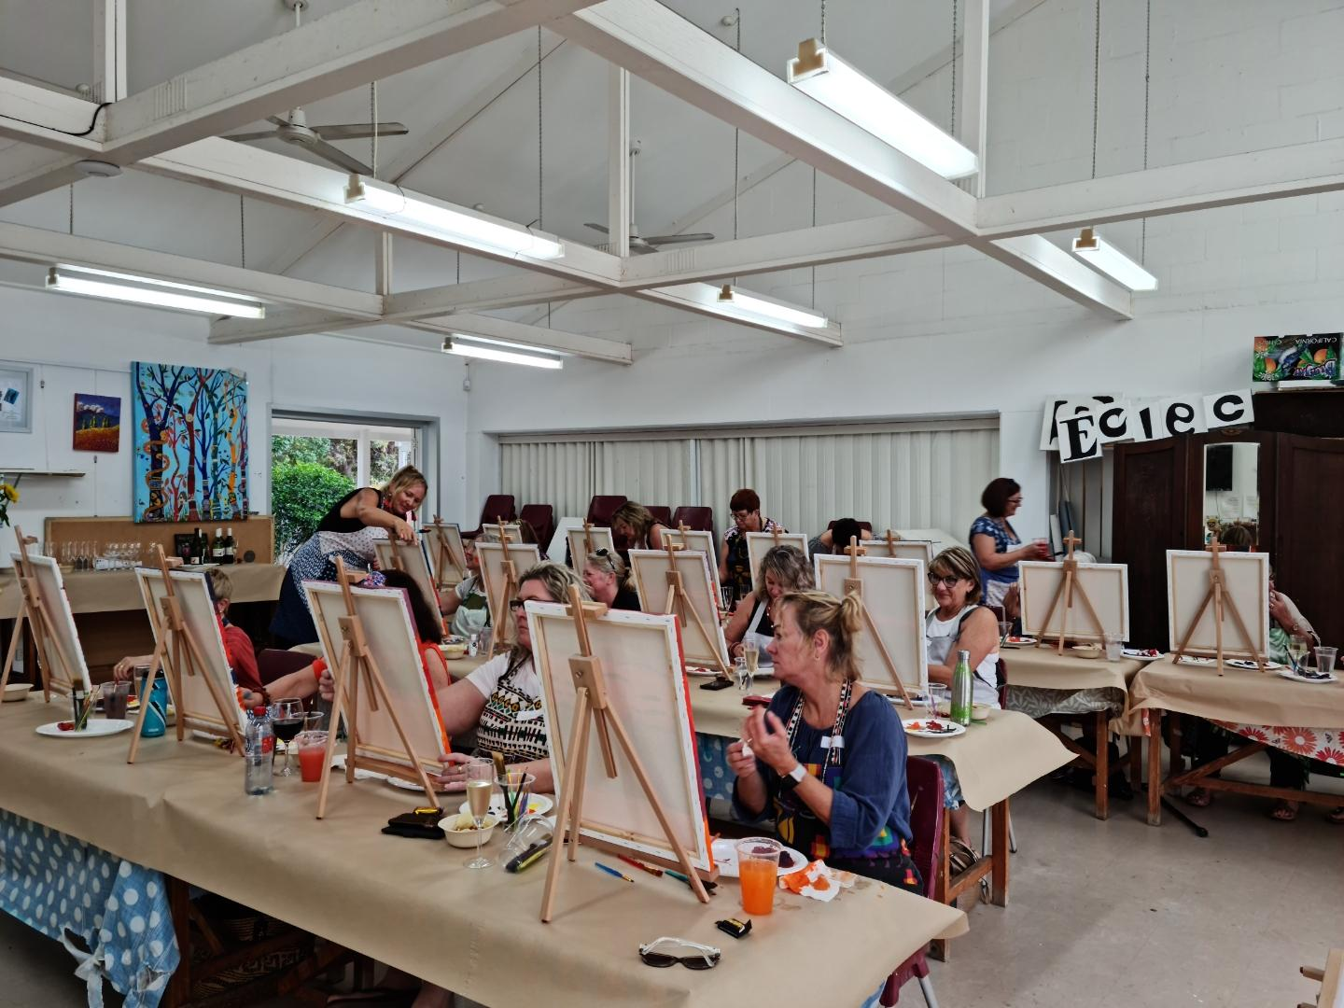

  - Come along to the Bribie Island Community Arts Centre on Saturday 6th of November 2pm-4pm.’Beach’ theme.
Enjoy an afternoon of painting and creating in a fun and supportive environment, all materials, nibbles and drinks are supplied.
Classes are a great way to find your inner artist and enjoy yourself.
Cost is $55 per person.
Bookings can be made online corinnepurcellart.com or phone 0438185173.

